Via Email Frankfurt, 14 February 2014

Invitation: TAFISA Certified Leadership Course in Sport for All,
in Cooperation with IOC
4th to 10th May 2014, Kuala Lumpur, Malaysia

Dear Colleague,

It is our pleasure to invite you on behalf of MARFIMA and TAFISA to the

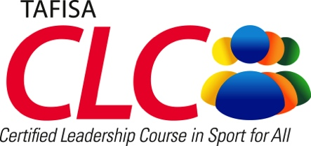
in cooperation with IOC

Venue: International Youth Centre, Cheras, Kuala Lumpur
Date: Arrival 4th May 2014, departure 10th May 2014

The Certified Leadership Course (CLC) program will focus on leadership and management skills in the areas of strategy building, volunteerism, Sport for All programs development, sport and social capital, and developing active cities, communities and citizens.

Participants who complete the course will be exposed to international perspectives, learn more about example programs, create new networks and apply what they have learned in creative planning to meet the future needs of their communities. Participants should currently work in the field of Sport for All in their country and must be able to communicate in English – the official course language. TAFISA CLCs are facilitated by accredited TAFISA lecturers, and successful participants will receive an internationally recognised graduation certificate.

The course location, Kuala Lumpur is one of Asia's most cosmopolitan and modern cities, but also housing many beautiful old buildings from a bygone era, green areas and friendly charm. KL offers a unique blend of old colonial and new Asian style, where Chinese tea houses, Indian shops and Malay hawker stalls line streets next to world-class hotels and super hi rise office blocks. During May the weather is typically between 23 and 31 degrees Celsius – a perfect time to visit Kuala Lumpur!

The registration fee for the course is US$350 for a twin shared room, or US$400 for a single room. This includes course registration fee, accommodation, local transport, meals, social program and course materials.

Once registration fee is received, MARFIMA will issue a formal letter to secure participant’s travel visa from the Malaysian foreign agency in the participant’s home country, if required.

For more information, please refer to the attached brochure and registration form or contact us at the TAFISA office. Registration forms should be returned to info@tafisa.net, marked ‘Attention Bae Schilling’, with copies of international passports no later than Friday, 4th April 2014.

Yours sincerely,

Wolfgang Baumann
Secretary General TAFISA

